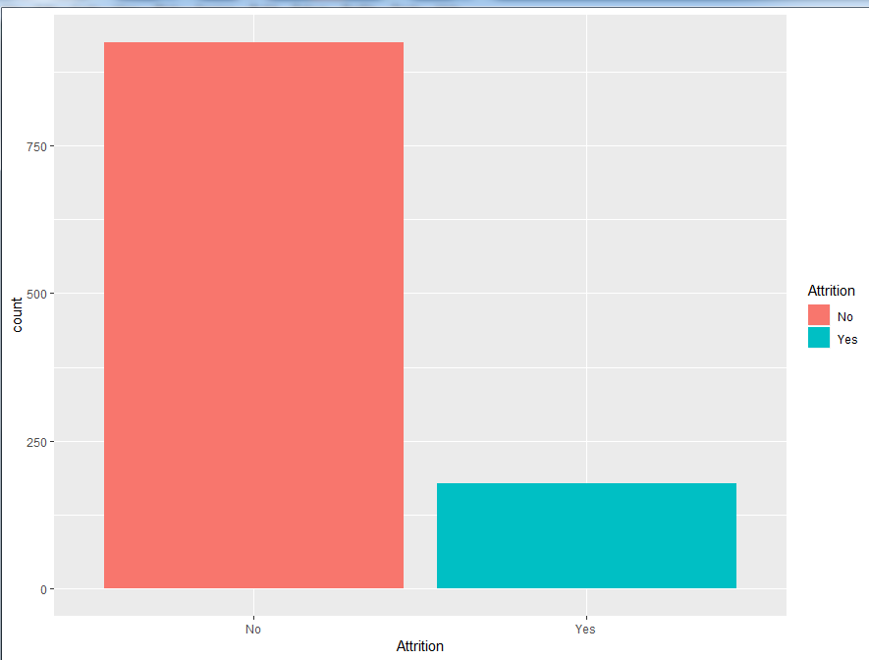

To find the propotion

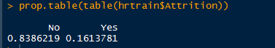

**To check the influence of each variable**

ageplot<-ggplot(hrtrain,aes(Age,fill=Attrition))+geom_density()+facet_grid(~Attrition)

ageplot

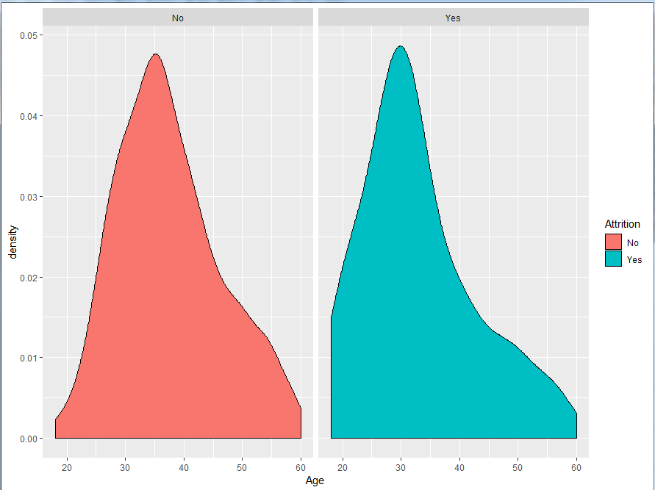

travelplot<-ggplot(hrtrain,aes(BusinessTravel,fill=Attrition))+geom_bar()

travelplot

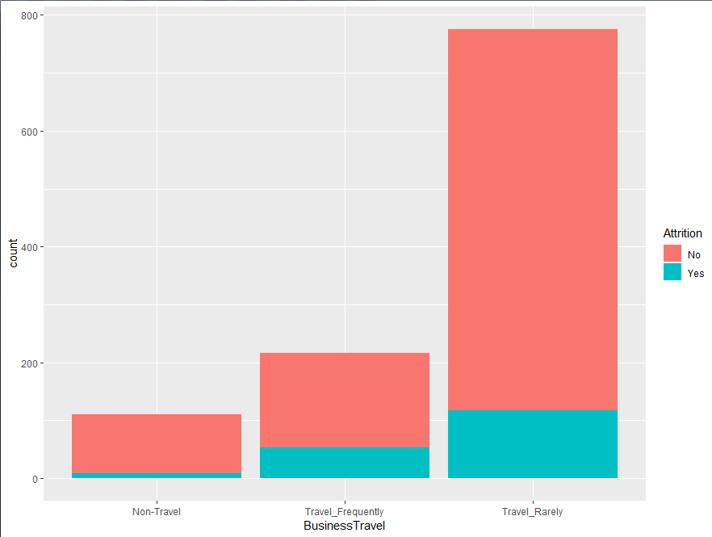

rateplot<-ggplot(hrtrain,aes(DailyRate,fill=Attrition))+geom_dotplot()

rateplot

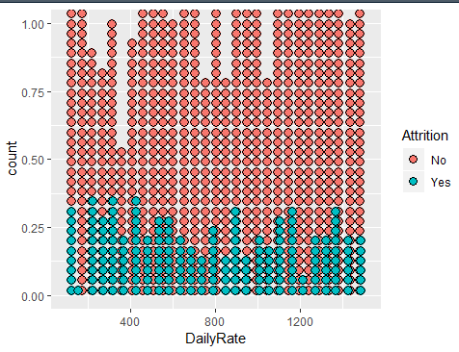

deptplot<-ggplot(hrtrain,aes(JobRole,fill=Attrition))+geom_bar()

deptplot

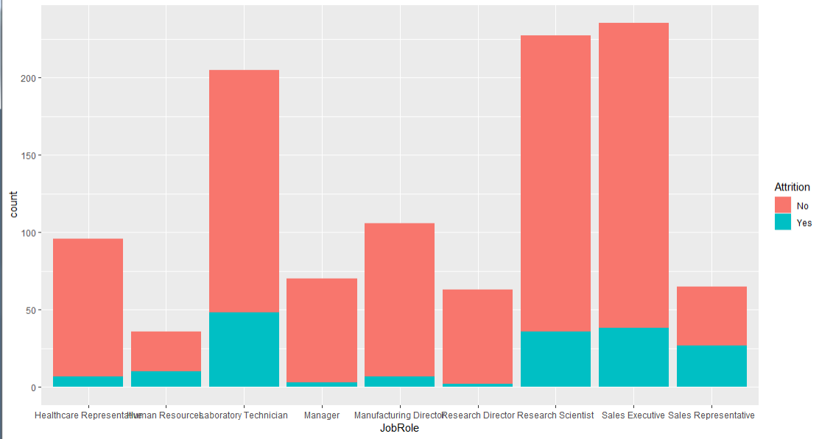

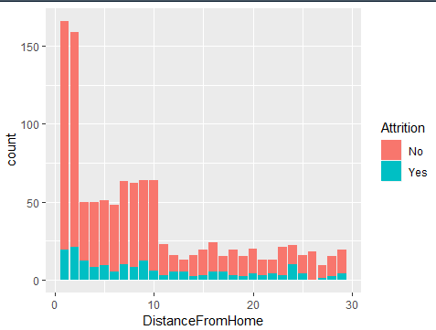

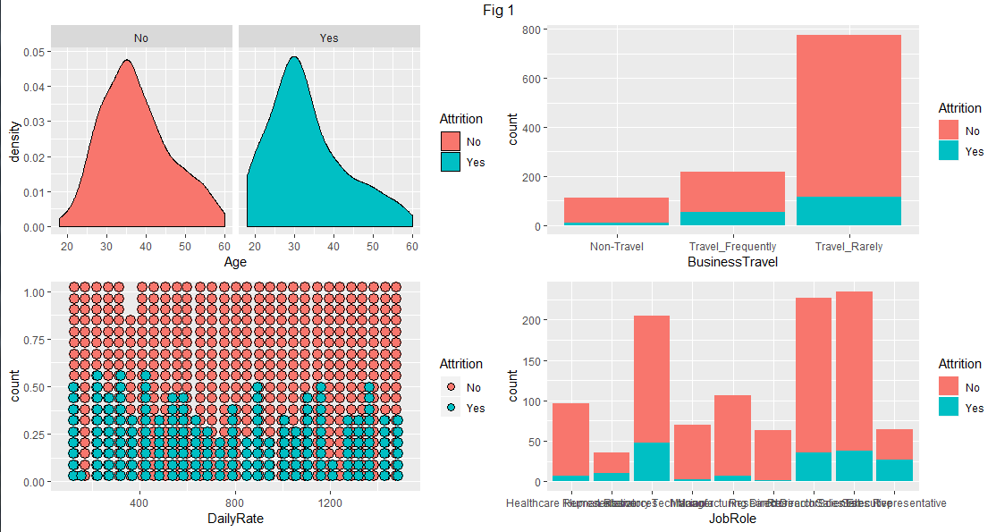

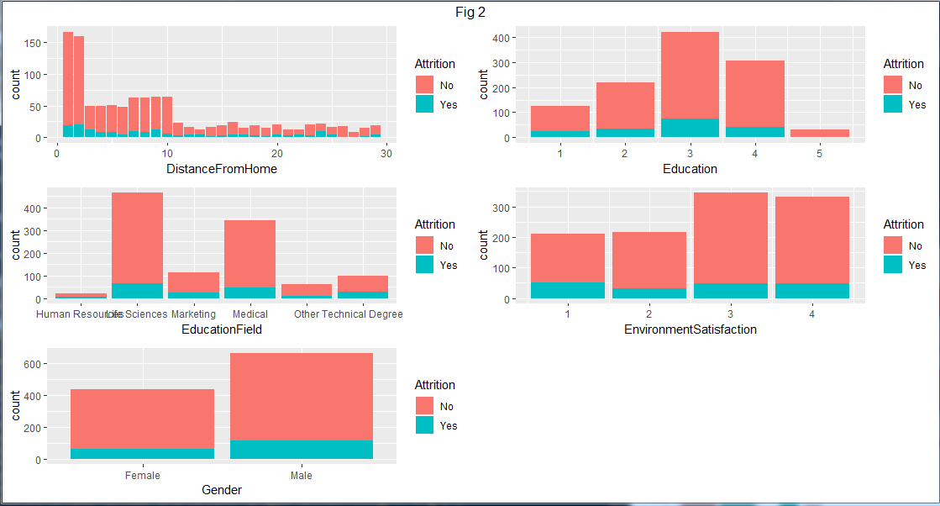

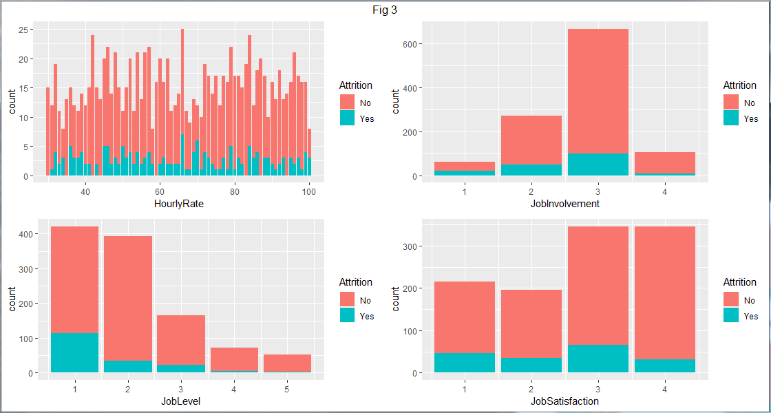

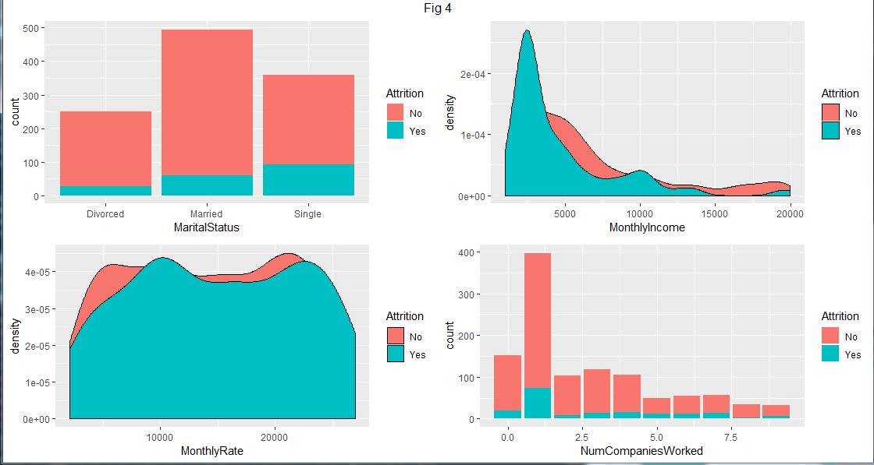

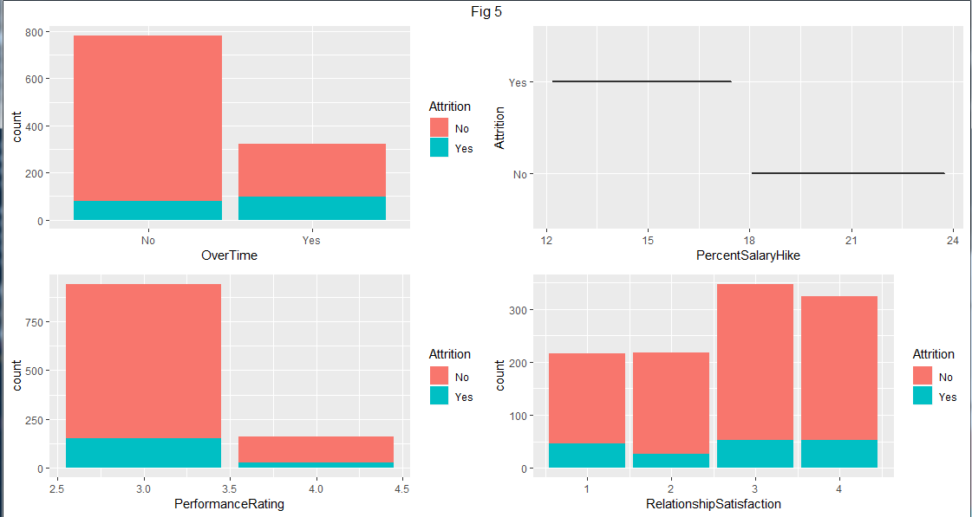

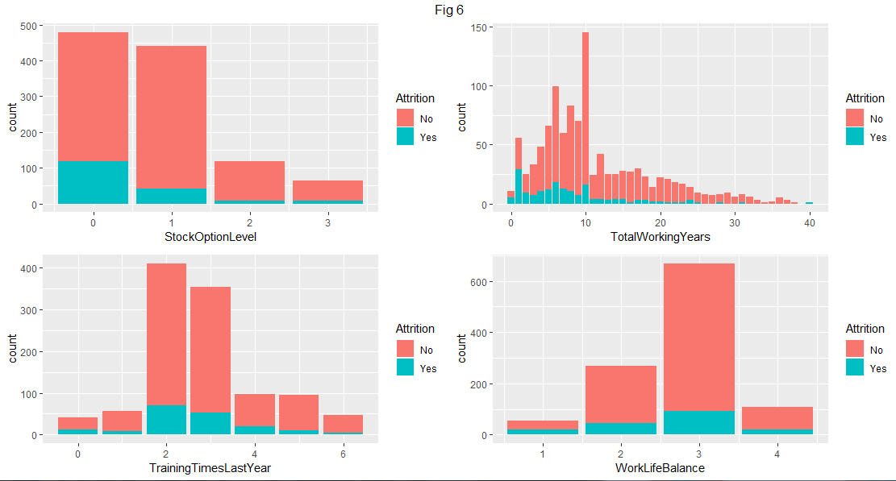

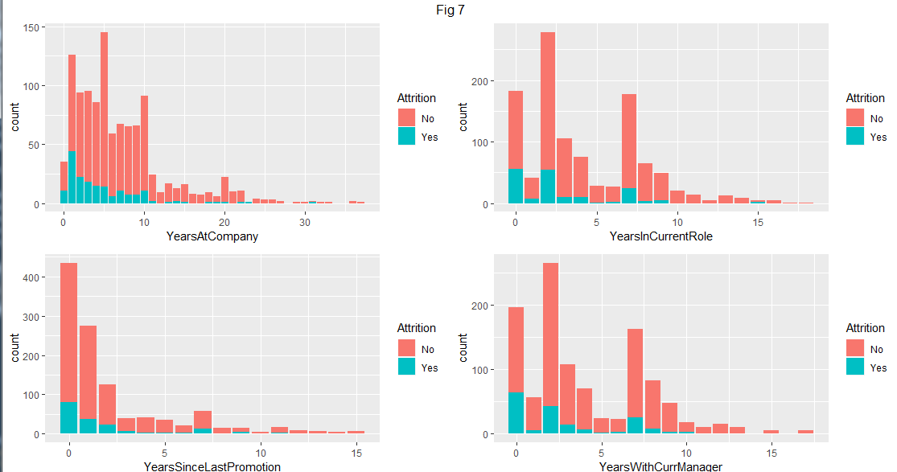

1. Age: We see that majority of employees leaving the org are between 30 - 40 Years .
2. Business Travel: Employees who travel rarely let the org.
3. Daily Rate: We see the uniformly distributed
4. Department:
5. Distance From Home: We see people who stay near the org have left the org.
6. Education: From the metadata we know that 1 ‘Below College’ 2 ‘College’ 3 ‘Bachelor’ 4 ‘Master’ 5 ‘Doctor’ . we see Bachelor has left the org but the number of people are also more in the org.
7. Education Field: On lines of the trend in Departments, a minority of HR educated employees leave and it is majorly because of low number of people.
8. Employee Count :.
9. Employee Number:.
10. Environment Satisfaction: Ratings stand for - 1 ‘Low’ 2 ‘Medium’ 3 ‘High’ 4 ‘Very High’ . We don’t see any distinguishable feature, but we see no of people are less with 1 has still we see propornatly more.
11. Gender: We see that majority of separated employees are Male
12. HourlyRate : We don’t get much inference from this. There also seems to be no straightforward relation with the Daily Rate of the employees.
13. Job Involvement: Ratings stand for 1 ‘Low’ 2 ‘Medium’ 3 ‘High’ 4 ‘Very High’. We see that majority of employees who leave are either Very Highly involved or Low Involved in their Jobs.
14. JobLevel:We have no metadata with regard to the numbers in Job Level. But by looking at proportion of people seems like 1 stands for entry level and 5 stands for highest level in our Dataset. By looking at plot we see that as the Job Level increases the number of people quitting decreases.
15. Job Satisfaction: As per metadata 1 ‘Low’ 2 ‘Medium’ 3 ‘High’ 4 ‘Very High’. We see higher attrition levels in among lower Job Satisfaction levels.
16. Marital Status:We see Single has more attrition.
17. Monthly Income: We see higher levels of attrition among the lower monthly income.
18. Monthly Rate: We don’t see any inferable trend from this. Also no straightforwad relation with Monthly Income.
19. Number of Companies Worked: We see a clear indication that many people who have worked only in One company before quit a lot.
20. Over18: Seems like an insignificant variable as all are above 18 Years.
21. Over Time: Larger Proportion of Overtime Employees are quitting.
22. Percent Salary Hike: We see that people with less than 17% hike have more chances to leave.
23. Performance Rating: 1 ‘Low’ 2 ‘Good’ 3 ‘Excellent’ 4 ‘Outstanding’. We see that we have employees of only 3 and 4 ratings. Lesser proportion of 4 raters quit.
24. Relationship Satisfaction: 1 ‘Low’ 2 ‘Medium’ 3 ‘High’ 4 ‘Very High’. Higher number of people with 3 or more rating are quitiing. But Larger proportions of 1 & 2 rating are quitting.
25. Standard Hours: Same for all and hence not a significant variable for us.
26. Stock Option Level: Larger proportions of levels 1 & 2 quit.
27. Total Working Years: We see larger proportions of people with 1 year of experiences quitting the organization also in bracket of 1-10 Years.
28. Traning Times Last Year: This indicates the no of training interventions the employee has attended. People who have been trained 2-4 times is an area of concern.
29. Work Life Balance:Ratings as per Metadata is 1 ‘Bad’ 2 ‘Good’ 3 ‘Better’ 4 ‘Best’. As expected larger proportion of 1 rating quit, but absolute number wise 2 & 3 are on higher side.
30. Years at Company: New comers are quitting the organization.
31. Years In Current Role: Plot shows a larger proportion with just 0 years quitting. May be a role change is a trigger for Quitting.
32. Years Since Last Promotion: Larger proportion of people who have been promoted recently have quit the organization. So this cannot be the reason for attrition
33. Years With Current Manager: As expected a new Manager is a big cause for quitting.